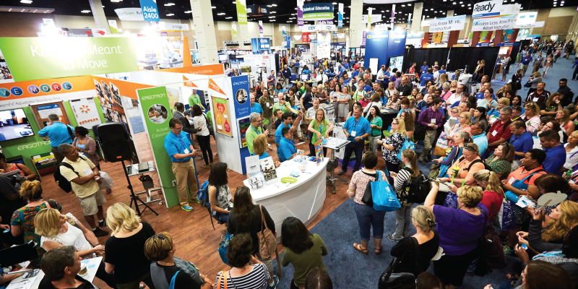

**UK Package**

**POD Package: £3200 includes**

**Full Stand Package (9sq mtrs): £4300**  
(*Exchange rate 1 GBP = 1.25 USD)

* Pod or Stand with Fascia
* Pipe railing with curtains (for full stands only)
* Bar stool (pods only)
* 5 Amp socket
* Standard internet connection
* BESA service
* Cleaning and Security
* Conference Badge
* Event Catalogue entry
* UK Brochure

**Visitor Profile**

1. Teachers, Educators & Principals
2. Decision makers
3. Technology directors
4. Librarians/Media specialists
5. Consultants & Curriculum coordinators/specialists
6. Policy makers

**2017 Key Statistics**

* 16,000+ educators
* Visitors from 75 nations
* 5,000+ industry reps
* Over 500 exhibitors

**DIT Support**

For this event, there are grants available from DIT. These are allocated on a first come first, served basis, providing you are eligible. The value of the grant is **£2000**. If you would like to exhibit and apply for a grant, please complete the booking, grant application and the T&Cs signed forms and send to yasmin@besa.org.uk. For companies that apply and are eligible for a grant, the grant will be paid 4 – 6 weeks after the event has taken place.

**The BESA Service**

From the moment you book a stand in the British Pavilion to the moment you return home after the exhibition, BESA’s international team will be with you every step of the way. Moreover, at no extra cost and on top of the stand package, UK companies within the UK pavilion will also get the following:

* Pod or Stand with carpet and red aisle carpet
* UK pavilion lounge with refreshments
* UK pavilion signage to attract delegates
* UK show guide
* Company logo on fascia
* Enhanced fascia with British flag

**General Information**

For more than three decades, the **ISTE Conference & Expo** has attracted 16,000 key decision-makers and influencers from across the globe looking to explore the latest innovations in EdTech. Annual surveys show that our attendees spend an average of six hours exploring the Expo, making it an unequalled global EdTech marketplace. ISTE understands that exhibiting requires a significant commitment of your time and resources. We view our relationship with you as a partnership. We are committed to your success and delivering the most valuable marketing and promotional opportunity possible. Exhibit at ISTE 2018 in Chicago, Illinois and show case your products and services to a highly targeted market of education professionals.