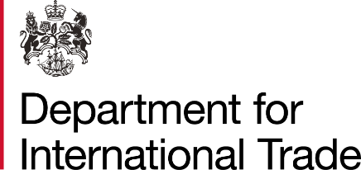

TRADESHOW ACCESS PROGRAMME (TAP) SUPPORT SCHEME FOR OVERSEAS EXHIBITIONS

TERMS AND CONDITIONS FOR EXHIBITORS
2020-2021

Between

British Educational Suppliers Association

on behalf of

THE SECRETARY OF STATE FOR THE DEPARTMENT FOR INTERNATIONAL TRADE

And

[INSERT NAMED EXHIBITOR]

FORM OF CONTRACT

PARTIES:

(1) THE SECRETARY OF STATE FOR THE DEPARTMENT FOR INTERNATIONAL TRADE of 3 Whitehall Place, London, SW1A 2AW;

AND

(2) [Insert full name of the Exhibitor] of [insert full address but if a registered company, please insert the following as appropriate] - registered in England, Wales, Scotland and Northern Ireland under number [insert company number] whose registered office is [insert address] (the “Participant”).

(each a “Party”, and together the “Parties”).

Signed: Date:

